

**Ain Shams University**

**Faculty of Engineering**

**Computer & Systems Engineering Department**

**CSE411: Distributed Computer Systems**

**Distributed online marketplace**

|  |  |
| --- | --- |
| Name: | Code: |
| Marina Kamal Barsoum | **1701103** |
| Madonna Yousry Youssef | **1701074** |
| Mary Wassem Khairy | **1701092** |
| Fady Zakria Akhnoukh | **1700962** |
| Fady Gamil Mahrous | **1700961** |

**Submitted by:**

Table of Contents

Introduction: 2

Target beneficiaries of the project: 3

Adopted programming language: 4

• **Front-end:** 4

• **Back-end:** 4

System architecture: 5

Application-level protocol: 6

1. Add to cart scenario: 6

2. Add new product scenario: 7

Distributed database design: 8

1. ER diagram: 8

2. Nosql schema: 9

9

Time plan: 10

**Phase1 tasks:** 10

**Phase2 tasks:** 10

**Phase3 tasks:** 10

**Phase4 tasks:** 10

Testing: 11

End-user Guide: 17

Resources needed: 24

Role of each member: 24

# Introduction:

This project is a distributed online marketplace, The system should rely on a distributed database model, where appropriate partitioning of the tables is designed.

Distributed database has great advantages and some of these advantages are that Data located near the greatest demand site, faster data access, faster data processing and growth facilitation.

This online marketplace will give the opportunity for all people to sell their products online without the need of physical shop or sales assistants, so the income will increase since no money will be spend on shop maintenance, electricity bills or salaries for employees. All you need is a stablished internet connection and account on our website.

Also, this website will give users the opportunity to purchase the desired products they need and giving them the freedom to choose from variety of options and to compare prices to get the most suitable offer for them.

Not only casual users can benefit from this website but also stores that need to expand their sales can have account on our website and show their products to be sold and so increasing their income.

At the end, our aim is encouraging and improving online shopping experience for all people by providing them a lot of features on our website to make online shopping easy and fun.

# 

# Target beneficiaries of the project:

* **Online shopping lovers:**

those who love shopping online can have account on our website and enjoy choosing from different categories and comparing prices to get the best offer, and being able to see products offered by other users

* **Stores’ owners:**

stores that need to sell their products at online website besides their existing physical markets to expand their sales and at the same time they cannot afford buying online website for them, they can easily have account on our website and show their products to be sold and so increasing their income.

* **People who need to start their business:**

People who don’t have enough capital to establish a physical market to start their business to sell certain products can benefit from our website and start their business only in two steps; have an account, add their products and finally it will be available for all users of our website. And also our website provide them different kinds of reports about transactions made.

# Adopted programming language:

* REST API webservice

## **Front-end:**

* Java script
* React.js
* redux

## **Back-end:**

* Node.js
* Express.js for building server and designing APIs
* NoSQL database using MongoDB as a source-available cross-platform

# System architecture:

* Users make requests on the website such as: browsing products, browsing other users and stores, making transactions such as: buying, selling, following a store, adding cash to their wallet … etc.

All these requests are handled by the server.

The server requests data stored from the distributed database. The database filter data according to the server request.

The server renders pages and handles all user’s transactions.

# Application-level protocol:

## Add to cart scenario:

## Add new product scenario:

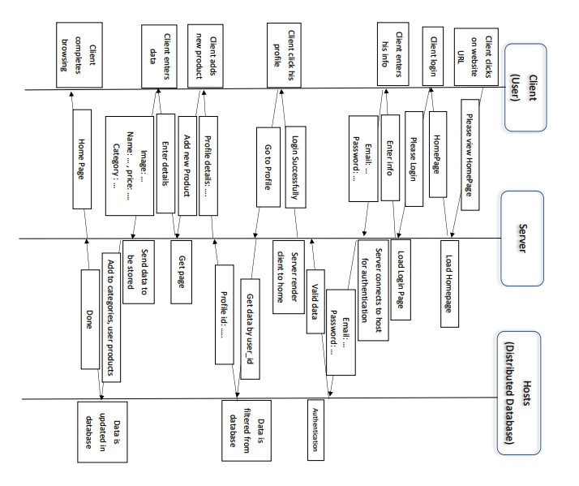

# Distributed database design:

## ER diagram:

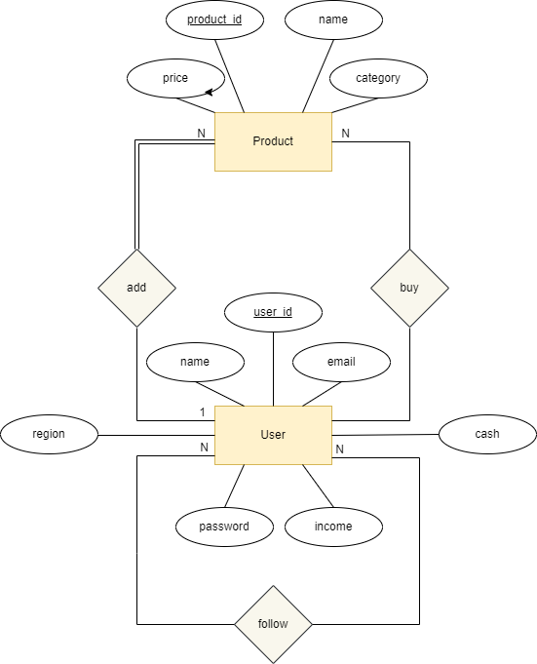

## Nosql schema:

# 

# Time plan:

## **Phase1 tasks:**

1. Learning different technologies to implement the website
2. Designing system architecture
3. Designing distributed database
4. Searching for how to connect distributed database

## **Phase2 tasks:**

1. implementing login view and login API
2. implementing register view and API
3. implementing home page and profile views
4. APIs for adding item to cart

## **Phase3 tasks:**

1. Enhancing design to be responsive
2. Implementing reports’ view and APIs
3. APIs for adding product and buying product
4. API for cash deposit and transferring money between accounts
5. Implementing distributed database

## **Phase4 tasks:**

1. Unit testing
2. System testing
3. documentation

# Testing:

component testing:

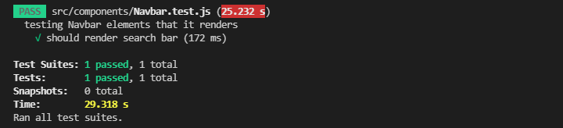

System testing:

**We mainly focus on this test that functional requirements of this software product are achieved**

1-User can login if he already has an account:

He will be directed to home page and now he can view his profile, add item, buy product….etc.

2-System doesn’t allow user to register without providing his password:

3-If user entered unmatched password during registration, it will show him a msg and won’t allow him to create new account:

4-user can add new product to be sold only if he has an account:

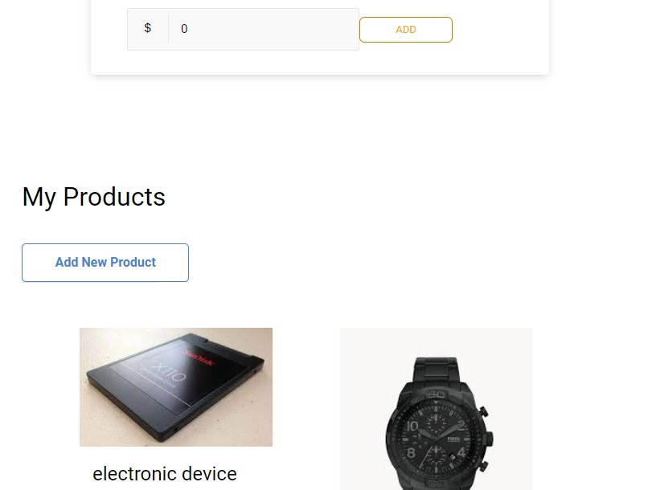

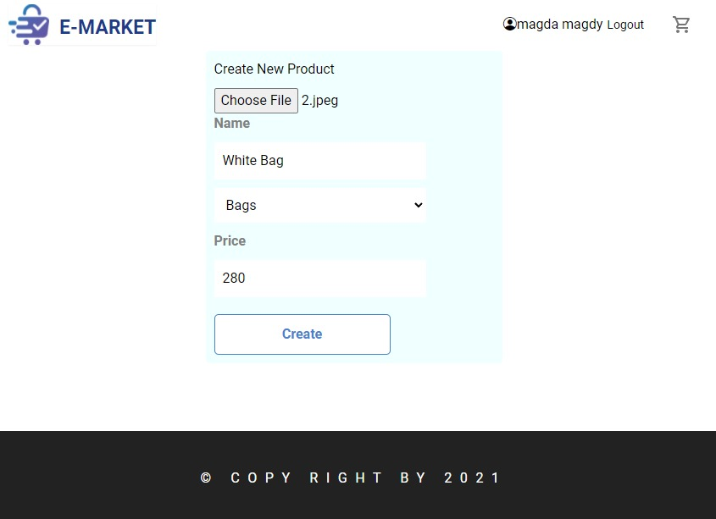

5-user can purchase item from another user:

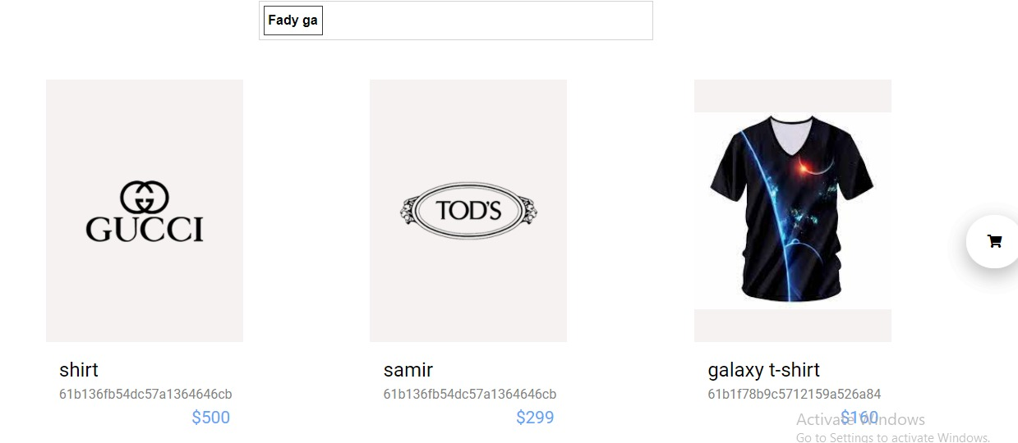

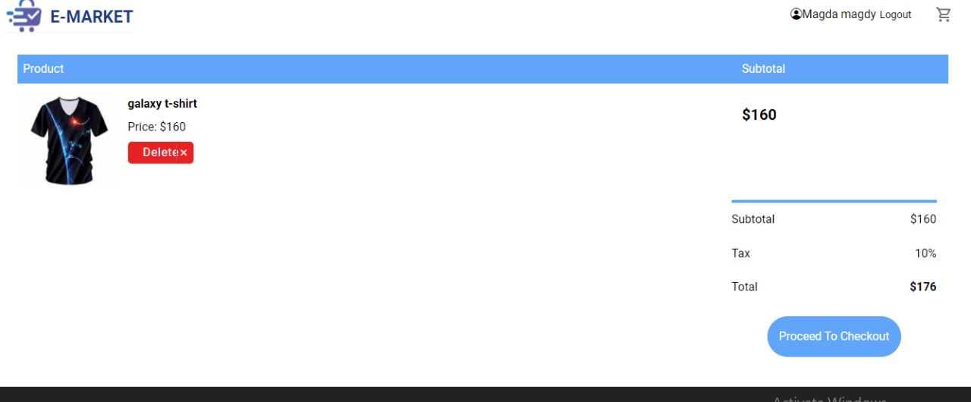

Cash before and after:

6-user can deposit cash in his account:

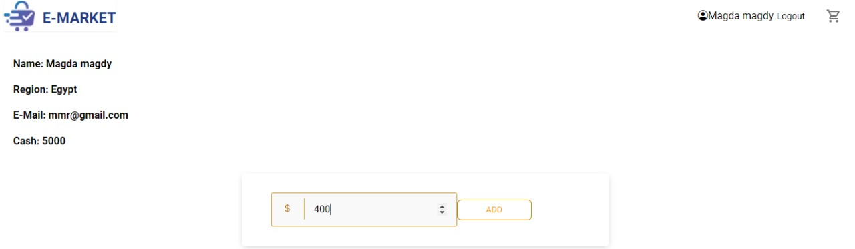

7-system can generate reports for different transactions user performed on system it will be shown in statistical view:



8-user can filter products by name of owner user:

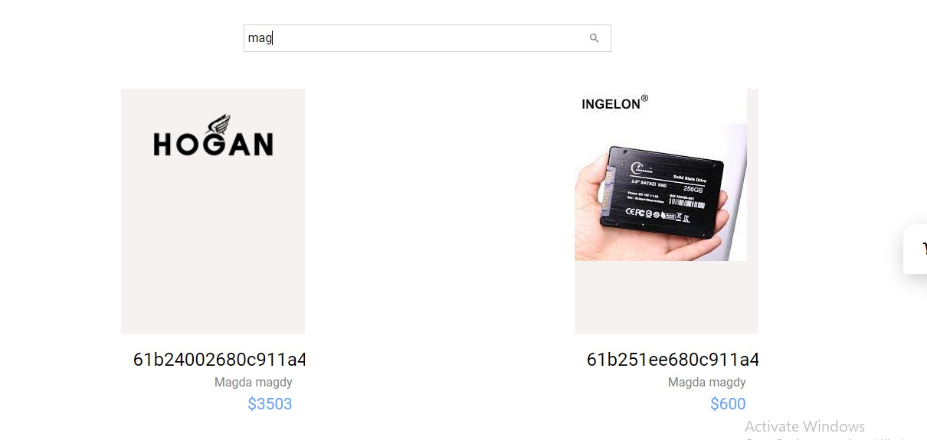

# End-user Guide:

For user who visit the website for the first time:

If he wants to have an account:

If user have an account and want to add product:

user press here to view his account

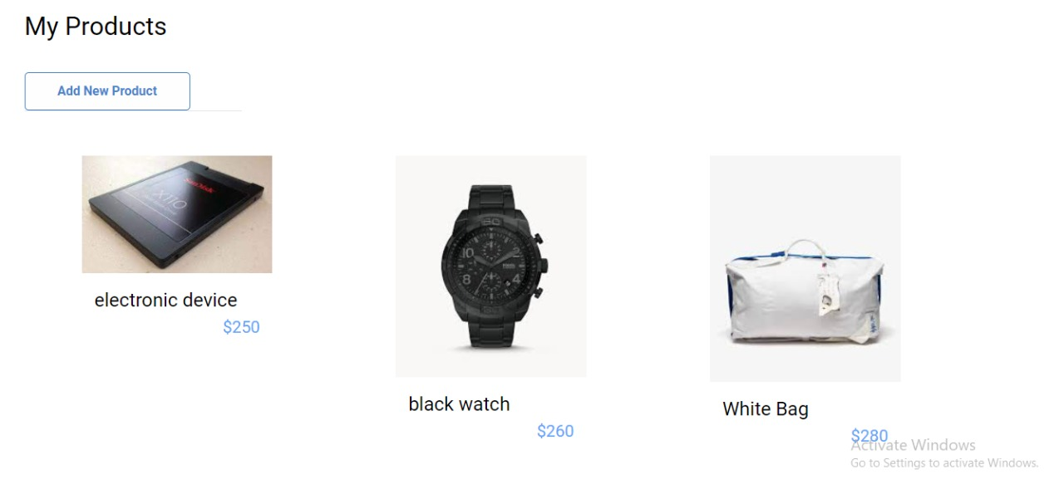

Item will be added in user products

If he wants to see reports generated:

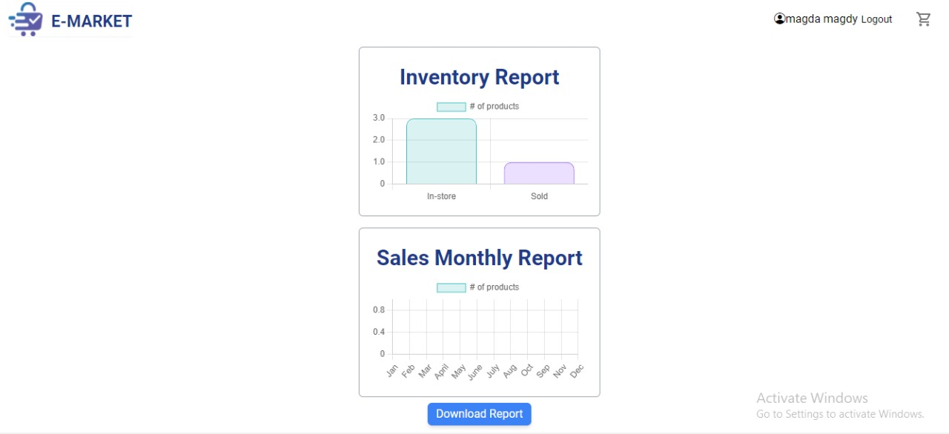

User can download the reports generated

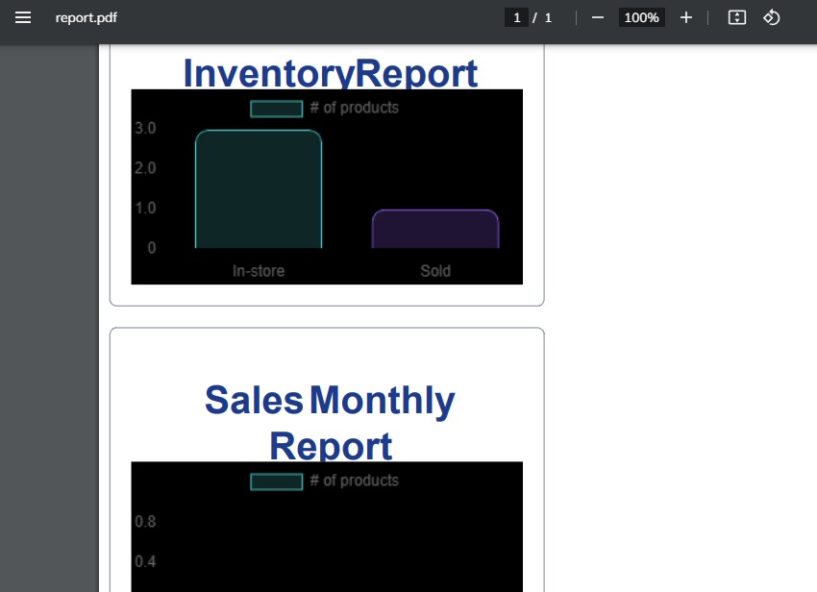

It will be downloaded in pdf file

If he wants to view his profile info and cash balance and deposit cash:



User adds the amount of cash

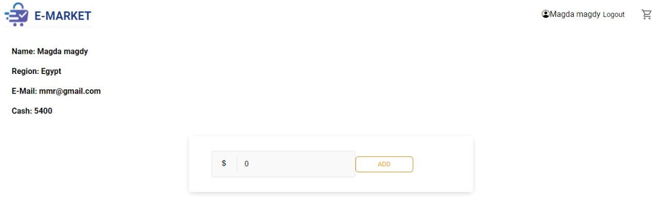

It will be added to his balance

If he wants to buy product:

User can buy item from certain user or store

User can follow another user

# Resources needed:

2 clusters of MongoDB each one hosted on a different host

Note: Each cluster have max 500 connections.

# Role of each member:

|  |  |
| --- | --- |
| Name: | Role: |
| Fady Gamil Mahrous | Back-end |
| Fady Zakaria Akhnoukh | Front-end |
| Marina Kamal Barsoum | Front-end |
| Madonna Yosry Youssef | Front-end |
| Mary Wassem Khairy | Back-end |